**Day 3 – Assignment Hung Le**

* **Write a program to get an integer input from user and outputs if the entered number is even or odd.**

let prompt = require('prompt-sync')();

let num = prompt("Please enter an integer number: ");

num = parseInt(num);

oddEvenCheck = num%2;

if (oddEvenCheck === 0) {

console.log("Even number");

} else if (oddEvenCheck !== 0) {

console.log("Odd number");

}

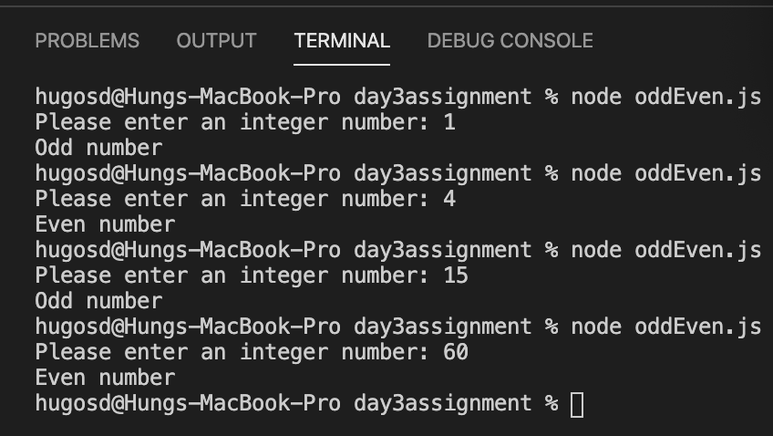

**Chapter 6 – Programming Assignment**

**Question 1:**

|  |  |  |
| --- | --- | --- |
| **Defining table** | | |
| **Input** | **Processing** | **Output** |
| * First number * Second number | * Subtract the first number from the second number. * Use Math.abs to get the absolute value. | * Absolute difference between two numbers entered by a user. |

let prompt = require('prompt-sync')();

let firstNum = prompt("Please enter the first number: ");

let secondNum = prompt("Please enter the second number: ");

let absDiffer = Math.abs(secondNum - firstNum);

console.log(absDiffer);

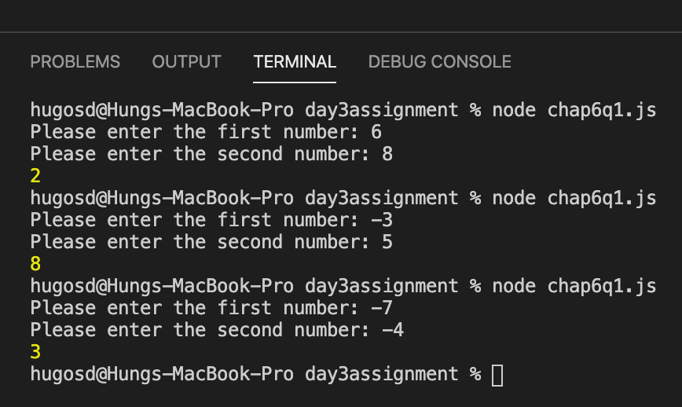

**Question 2:**

|  |  |  |
| --- | --- | --- |
| **Defining table** | | |
| **Input** | **Processing** | **Output** |
| * Weather types: hot, rain, snow | * Match weather types with correct foot wears: * hot – sandals * rain – galoshes * snow – boots * else - shoes | * Correct foot wear for the day’s weather type |

let prompt = require('prompt-sync')();

let weather = prompt('How is the weather today?: ');

let footWear;

if (weather === "hot") {

footWear = "sandals";

} else if (weather === "rain") {

footWear = "galoshes";

} else if (weather === "snow") {

footWear = "boots";

} else {

footWear = "shoes";

}

console.log(footWear);

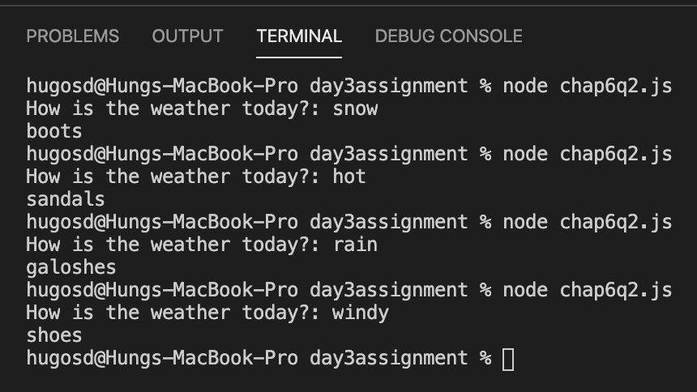

**Question 3:**

|  |  |  |
| --- | --- | --- |
| **Defining table** | | |
| **Input** | **Processing** | **Output** |
| * Student’s name * Number of completed university credits | * Match number of credits with year in school * Number of credits < 30 is freshman * Number of credits < 60 is sophomore * Number of credits < 90 is junior * Number of credits > 90 is senior | * Student’s name and year in school |

let prompt = require('prompt-sync')();

let studentName = prompt("What is the student's name?: ");

let creditNumber = prompt("How many credits did the student complete?: ");

let yearInSchool;

if (creditNumber < 30) {

yearInSchool = "freshman";

} else if (creditNumber < 60) {

yearInSchool = "sophomore";

} else if (creditNumber < 90) {

yearInSchool = "junior";

} else if (creditNumber >= 90) {

yearInSchool = "senior";

}

console.log(`${studentName} is ${yearInSchool}`);

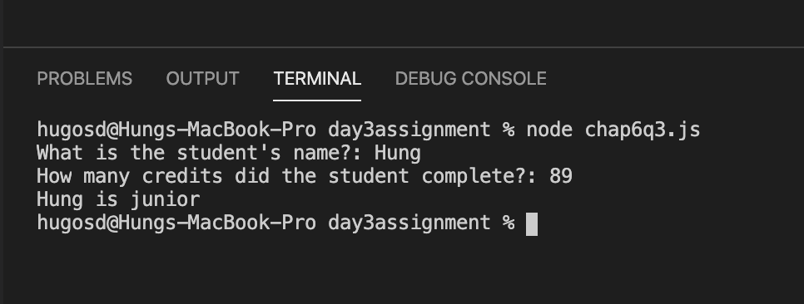

**Question 4:**

|  |  |  |
| --- | --- | --- |
| **Defining table** | | |
| **Input** | **Processing** | **Output** |
| * Cost of the house | * Calculate the down payment * Cost < 50000, down payment = cost * 0.05 * Cost < 100000, down payment = 2000 +0.1*(cost – 50000) * Cost < 200000, down payment = 7500 + 0.2*(cost – 100000) * Cost >200000, down payment = 27500 + 0.25*(cost – 200000) | * Down payment |

let prompt = require('prompt-sync')();

let cost = prompt("How much is the house?: ");

cost = parseFloat(cost);

let downPayment;

if (cost < 50000) {

downPayment = cost*0.05;

} else if (cost < 100000) {

downPayment = 2000 + 0.1*(cost - 50000)

} else if (cost < 200000) {

downPayment = 7500 + 0.2*(cost - 100000)

} else if (cost >= 200000) {

downPayment = 27500 + 0.25*(cost - 200000)

}

console.log("\$" + downPayment);

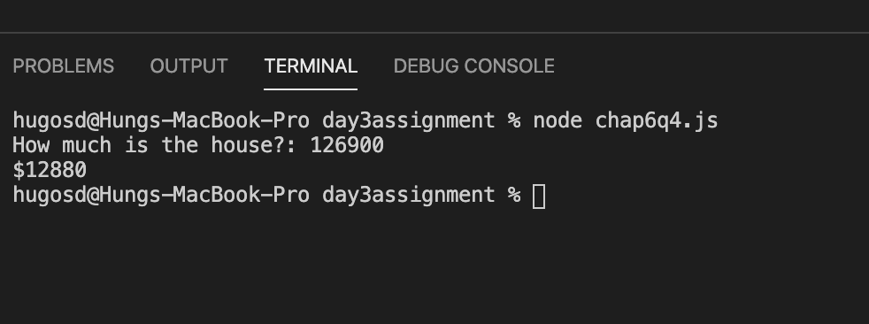

**Question 5:**

|  |  |  |
| --- | --- | --- |
| **Defining table** | | |
| **Input** | **Processing** | **Output** |
| * Person’s status * Number of books the person has kept past the due date in the last year | * Calculate how long a person may borrow a book. * Student and overdue book = 0 🡪 loan duration = 6 weeks * Student and overdue book < 3 🡪 loan duration = 4 weeks * Student and overdue book >= 3 🡪 loan duration = 2 weeks * Faculty and overdue book = 0 🡪 loan duration = 16 weeks * Faculty and overdue book < 3 🡪 loan duration = 12 weeks * Faculty and overdue book > = 3 🡪 loan duration = 8 weeks * Other and overdue book = 0 🡪 loan duration = 4 weeks * Other and overdue book < 3 🡪 loan duration = 3 weeks * Other and overdue book >= 3 🡪 loan duration = 2 weeks | * How long a person may borrow a book |

let prompt = require("prompt-sync")();

let status = prompt("Is the person a student, a faculty or other?: ");

let overdueBook = prompt("How many books has this person kept past the due date in the last year: ");

overdueBook = parseInt(overdueBook);

let loanDuration;

if (status === "student" && overdueBook === 0) {

loanDuration = 6;

} else if (status === "student" && overdueBook < 3) {

loanDuration = 4;

} else if (status === "student" && overdueBook >= 3) {

loanDuration = 2;

} else if (status === "faculty" && overdueBook === 0) {

loanDuration = 16;

} else if (status === "faculty" && overdueBook < 3) {

loanDuration = 12;

} else if (status === "faculty" && overdueBook >= 3) {

loanDuration = 8;

} else if (status === "other" && overdueBook === 0) {

loanDuration = 4;

} else if (status === "other" && overdueBook < 3) {

loanDuration = 3;

} else if (status === "other" && overdueBook >= 3) {

loanDuration = 2;

}

console.log("Loan duration is " + loanDuration + " weeks");

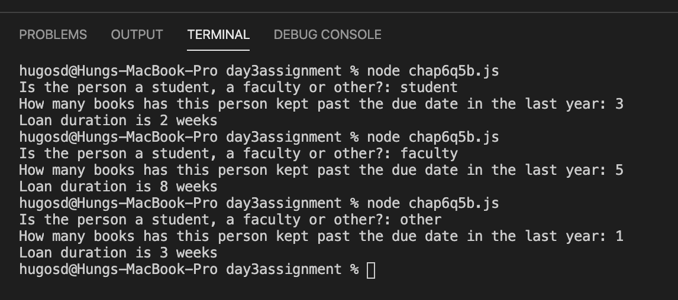

**Chapter 7 – Programming Assignments**

**Question 5:**

|  |  |  |
| --- | --- | --- |
| **Defining table** | | |
| **Input** | **Processing** | **Output** |
| * A child’s age * Season | * Calculate a child’s bedtime * Age < 6 and season is summer or fall 🡪 bedtime = 8:30pm * Age < 6 and season is winter or spring 🡪 bedtime = 8:00pm * Age <13 and season is summer 🡪 bedtime is 9:30pm * Age <13 and season is winter or spring or fall 🡪 bedtime is 8:30pm * Age >= 13 and season is summer 🡪 bedtime is 10:30pm * Age >=13 and season is winter or spring or fall 🡪 bedtime is 9:30pm | * A child’s bedtime |

let prompt = require('prompt-sync')();

let age = prompt("How old is the child?: ");

let season = prompt("What is the current season? summer, fall, winter or spring?: ");

age = parseInt(age);

let bedTime;

if (age <6 && (season === "summer" || season === "fall")) {

bedTime = "8:30 p.m.";

} else if (age < 6 && (season === "winter" || season === "spring")) {

bedTime = "8:00 p.m."

} else if (age < 13 && season === "summer") {

bedTime = "9:30 p.m.";

} else if (age < 13 && (season === "winter" || season === "spring" || season === "fall")) {

bedTime = "8:30 p.m.";

} else if (age >= 13 && season === "summer") {

bedTime = "10:30 p.m.";

} else if (age >= 13 && (season === "winter" || season === "spring" || season === "fall")) {

bedTime = "9:30 p.m.";

}

console.log(bedTime);

